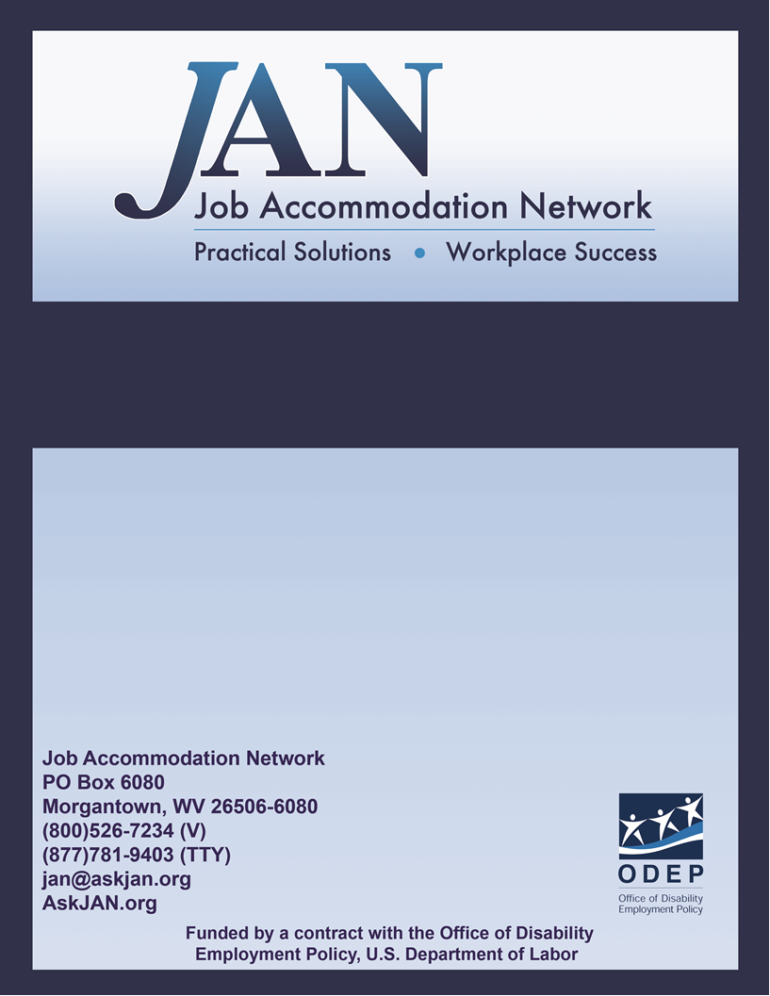
Effective Accommodation Practices (EAP) Series

Employees Experiencing Workplace Harassment

JAN’S EFFECTIVE ACCOMMODATION PRACTICES SERIES

Introduction
Information about Workplace Harassment
Workplace harassment has been given many labels, including bullying, harassment, workplace violence, and mobbing (Schindler, 2014). Mobbing entails multiple people bullying or harassing one individual (Vickers, 2009). The United States government defines workplace harassment as “unwelcome conduct that is based on race, color, religion, sex (including pregnancy), national origin, age (40 or older), disability or genetic information” (U.S. Equal Employment Opportunity Commission, Harassment, § 2). “To be unlawful, the conduct must create a work environment that would be intimidating, hostile, or offensive to reasonable people” (ibid, § 3).
Harassment may be committed by any employee, including co-workers, supervisors, support staff, employers or non-employees (e.g., delivery people or contractors). Likewise, any employee can be harassed by one or more others, although it is less likely that a person with little power will harass a person with greater power within the organization. In a study of workplace bullying, Namie, Christensen and Phillips (2014) found that more than half (56%) of the bullies have a higher rank than the victim, with 7% of the bullies being of lower rank. In this same study, mobbing (more than one bully) occurred in 23% of the cases.
There is some evidence that people with disabilities may be at increased risk of workplace harassment. Much of the research on harassment of people with disabilities has been conducted with children and adolescents within the school environment. This research suggests that those with emotional or behavioral disorders are at greater risk of harassment than others (e.g., Blake, Lund, Zhou, Kwok & Benz, 2012). Individuals with emotional or behavioral disorders may be viewed by others as a nuisance or thought to willfully engage in behaviors that may be disruptive. Consequently, others may engage in harassing or even aggressive behaviors toward them.
Addressing Workplace Harassment
Workplace harassment is considered a form of discrimination, and is therefore a violation of federal law. It is considered a violation of Title VII of the Civil Rights Acts of 1964, the Age Discrimination in Employment Act of 1976, and the 1990 Americans with Disabilities Act. The best policy is to address workplace harassment before it occurs by establishing a workplace culture of respect and no tolerance for harassment. However, harassment must be addressed once it has occurred.
If you or someone you know is being harassed at work:
- If you feel it may be effective or appropriate, you may attempt to address the harassment with the person by whom you are being harassed. If the person engaging in the harassment is a superior or the harassment is in any way threatening violence or by multiple people, then you may need to move to more formal measures of resolution.
- Document the words or language used that constitute the harassment. Remember, words are harassment when a reasonable person would feel uncomfortable, intimidated, threatened, unwelcomed, degraded, humiliated, or would view the language as offensive (Von Bergen, Zavaletta & Soper, 2006).
- Document the specific behaviors that constitute the harassment. Harassing behaviors may lie on a continuum, from incivility to physical violence (Von Bergen et al., 2006). Some behaviors that have been identified as bullying or harassment include humiliating treatment, exclusion, “unrealistically high workloads or deadlines, and physical intimidation or abuse” (Altman, 2010, p. 22).
- Make a copy of the documentation to give to your supervisor.
- Report the harassment to a supervisor, with as many details of the harassment as possible. With the lists of language and behaviors in writing you will be able to stay focused and to the point.

Resources
The United States Equal Employment Opportunity Commission’s website offers important information about your rights as an employee. Follow the link to legal information about workplace harassment: http://www.eeoc.gov/laws/types/harassment.cfm

The US EEOC website also offers information about illegal discrimination at http://www.eeoc.gov/laws/types/disability.cfm
The United States Department of Labor (DOL) has an informative website about unlawful workplace harassment for DOL employees, although the information is helpful to others: http://www.dol.gov/oasam/programs/crc/2011-workplace-harassment.htm

References
Altman, B. (2010). Workplace bullying: Application of Novak’s (1998) learning theory and implications for training. Employee Responsibilities and Rights Journal, 22, 21-32. DOI: 10.1007/s10672-009-9121-7
Blake, J. J., Lund, E. M., Zhou, Q., Kwok, O., & Benz, M. R. (2012). National prevalence rates of bully victimization among students with disabilities in the United States. School Psychology Quarterly, 27, 210-222. DOI: 10.1037/spq0000008
Namie, G., Christensen, D., & Phillips, D. (2014). 2104 WBI U.S. workplace bullying survey. Retrieved from the world-wide-web: http://workplacebullying.org/multi/pdf/WBI-2014-US-Survey.pdf
Schindler, E. (2014). Workplace violence: Extending the boundaries of criminology. Theoretical Criminology, 18, 371-385. DOI: 10.1177/1362480613511980
U.S. Equal Employment Opportunity Commission (n.d.). Harassment. Retrieved from the world-wide web: http://www.eeoc.gov/laws/types/harassment.cfm
Vickers, M. H. (2009). Bullying, disability and work: A case study of workplace bullying. Qualitative Research in Organizations and Management: An International Journal, 4, 255-272. DOI: 10.1108/17465640911002536
Von Bergen, C. W., Zavaletta, J. A., & Soper, B. (2006). Legal remedies for workplace bullying: Grabbing the bully by the horns. Employee Relations Law Journal, 32(3), 14-40.

Authored by Jeff Daniels, Ph.D., Updated 05/31/2018

This document was developed by the Job Accommodation Network, funded by a contract from the U.S. Department of Labor, Office of Disability Employment Policy (#1605DC-17-C-0038). The opinions expressed herein do not necessarily reflect the position or policy of the U.S. Department of Labor. Nor does mention of tradenames, commercial products, or organizations imply endorsement by the U.S. Department of Labor.

